MLPS 2.0 Compliance for Log360
Strengthen cybersecurity and meet MLPS 2.0 compliance with Log360.
Region: USA, China | Type: Industry Standard | Category: Compliance | Pricing: Free

Overview
The MLPS 2.0 compliance extension in Log360 helps organizations meet China's Multi-Level Protection Scheme 2.0 (GB/T 22239-2019), the mandatory cybersecurity classification regime requiring all network operators to classify systems into five protection levels enforced by the Ministry of Public Security by providing centralized log management, network monitoring, and security event correlation. The platform supports MLPS 2.0 requirements for system classification, network boundary protection, access control, audit logging, intrusion detection, data encryption, host security, and security operations management.
For Security Classification and Asset Inventory, Log360 inventories Windows programs, computer assets, network device configurations, and virtualization infrastructure to support the grading and registration process required by GB/T 22239-2019. To address Network Security and Boundary Protection, the platform monitors network device rule changes, firewall policy management, security reports, attack alerts, and Windows firewall events to validate boundary enforcement. The extension also supports Access Control and Identity Management by providing capabilities that tracks all logon events, authentication failures, MFA usage, AD logon activity, and user management changes to enforce access control across classified network systems.

Key Features
- Audit Logging and Continuous Monitoring: Log360 collects Windows event logs, database audit trails, system events, process tracking, and application logs to satisfy MLPS 2.0 audit logging requirements at all protection levels.
- Intrusion Detection and Prevention: Log360 aggregates antivirus threat alerts, Windows and Unix threat detection events, network attack reports, and third-party security tool data from FireEye, Trend Micro.
- Data Security and Encryption Controls: Log360 monitors file changes, Windows registry modifications, removable media activity, and DLP events to detect unauthorized access to or exfiltration of classified data.
- Host Security and Endpoint Protection: Log360 monitors Windows software update events, application whitelisting alerts, program inventory changes, and antivirus activities to validate host security compliance.
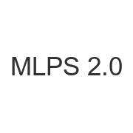
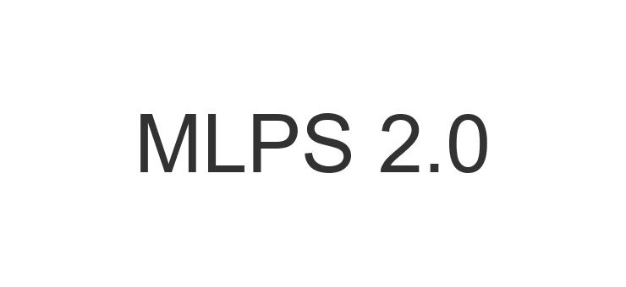
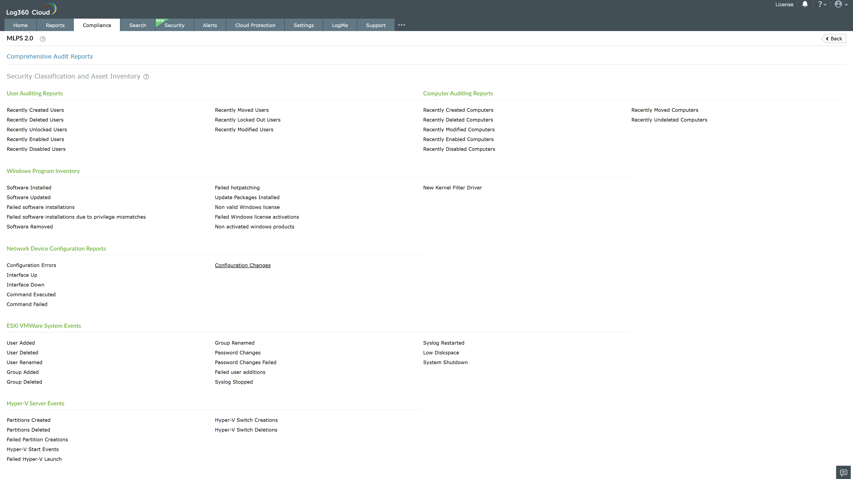
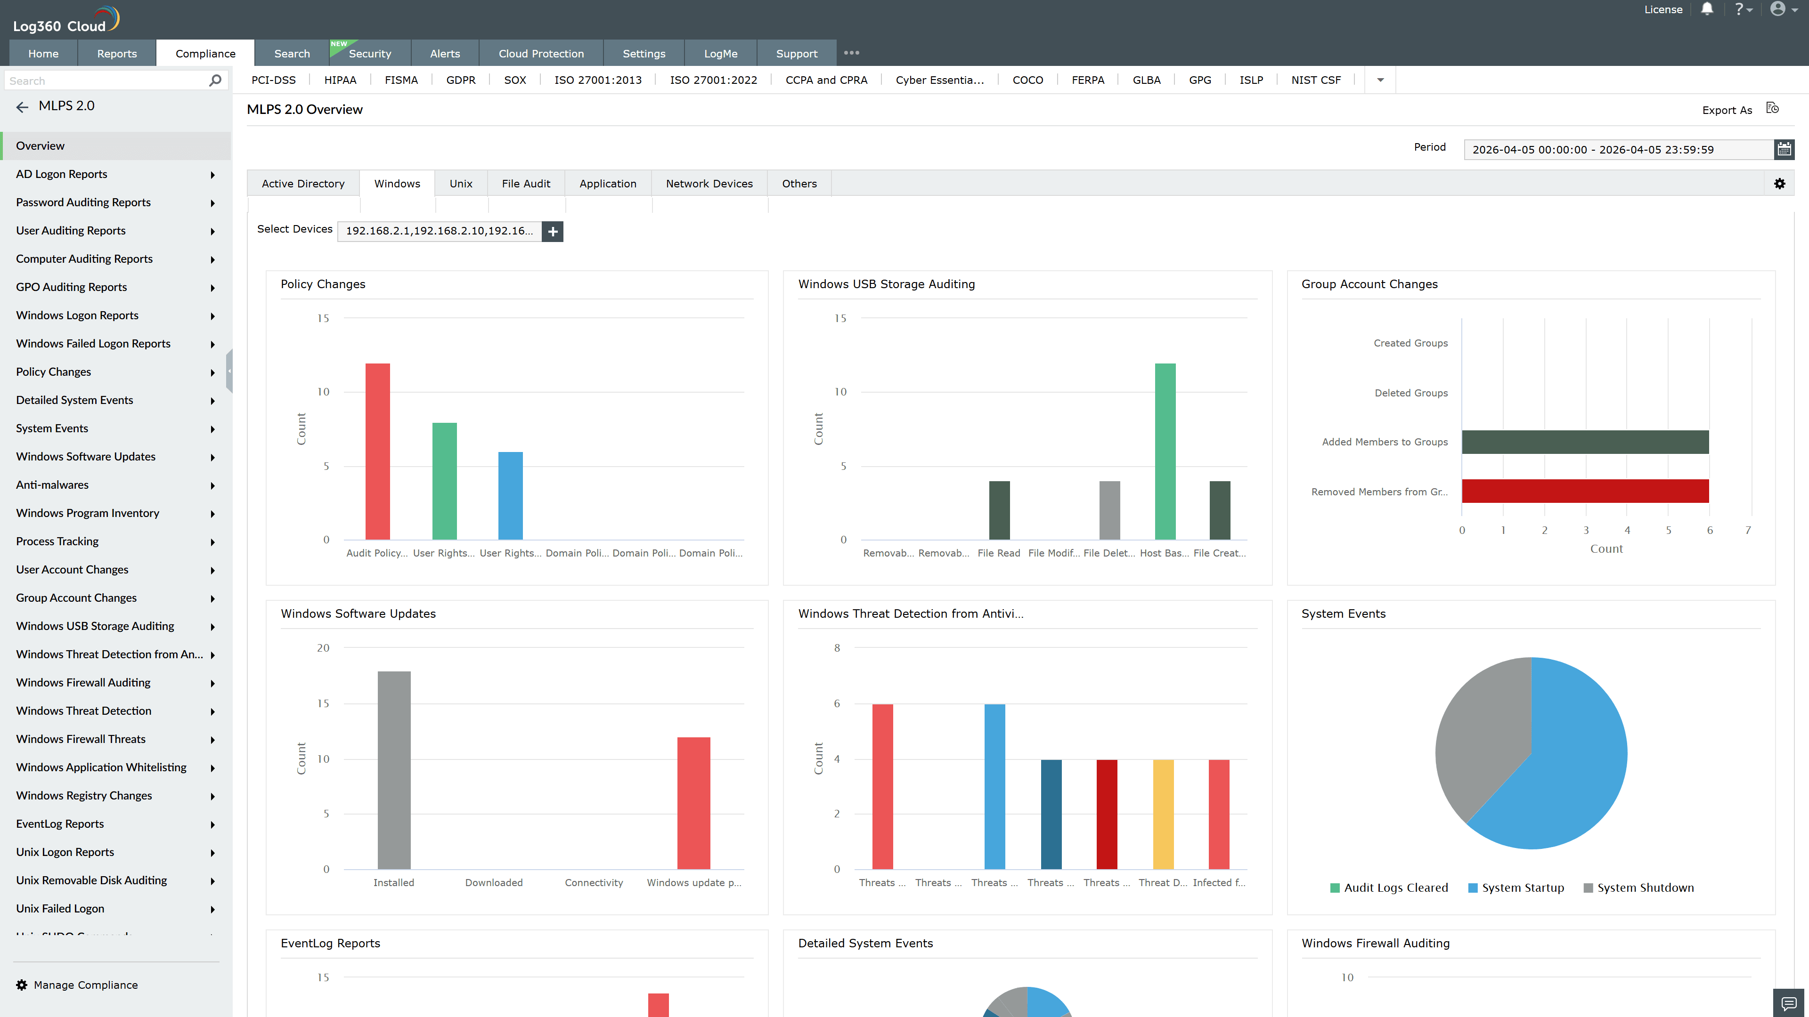
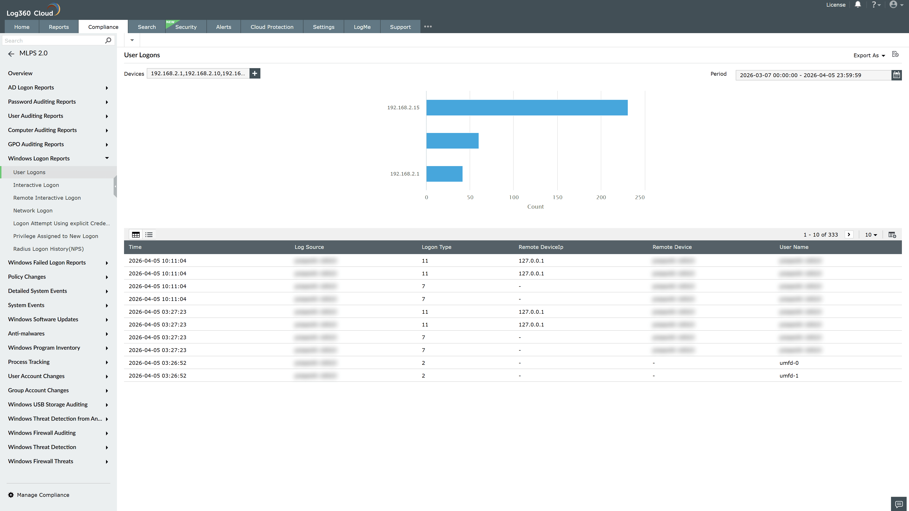
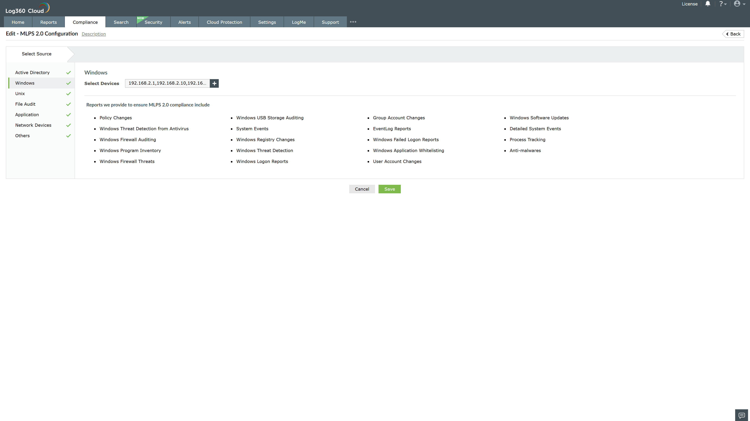
Valid Submission : Yes
Supported Editions : Free, Basic, Standard, Professional, MSSP
Help Document : https://www.manageengine.com/log-management/help/integrations/compliance-extensions.html
Help Video : Not provided
Tags : Log360, Compliance, Privacy monitoring, Data privacy, Regulatory compliance
Supported DCs : US, IN, JP, CA, AU, UK and EU
Privacy Policy:
Terms of Service:
Release Notes:
Predefined reports for the MLPS 2.0.

